UTSHAB KUMAR GHOSH

* [kumarutshab@gmail.com](mailto:kumarutshab@gmail.com)  +880-1701-067875

 linkedin.com/in/utshabkg  utshabkg.github.io

* Dhaka, Bangldesh

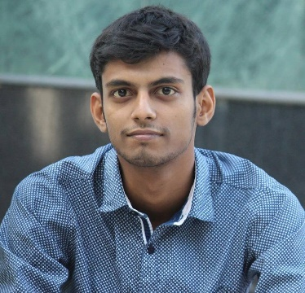Hiring Authority,

[**Foodpanda**](https://www.linkedin.com/company/wundermanthompsondhaka/life/) **Bangladesh**

Dear Sir/Madam,

Thank you for the opportunity to apply for the **Business Intelligence Analyst (Marketing)** role at [*Foodpanda*](https://www.linkedin.com/company/wundermanthompsondhaka/life/) *Bangladesh*. After reviewing the job description, it's clear that you're looking for a candidate who is familiar with the responsibilities associated with the role and can perform them confidently.

I have completed my **B.Sc. in** *Computer Science & Engineering* at *Rajshahi University of Engineering & Technology* with a **CGPA of 3.22**. I have been working with Machine Learning and Data Science for about **3+ years**. I had the privilege of working for ***MyMedicalHUB*** in an **AI Research Assistant** role, where I worked on **Video and Image Analysis Projects**, with my skillset of **Python, Javascript, SQL, Computer Vision**, **Deep Learning**, **AWS**, **Apace Server**, **REST API**, and so on. I am a regular attendee of Data Science and Machine Learning **Competitions** on **Kaggle, HackerEarth, Datahack,** etc. I am an **x3 Kaggle Expert** with Applied Data Science and Deep Learning **specializations**. I am also an **analytical problem solver** with **300+ solves** on online judges like **Codeforces, Codechef, LightOJ,** etc.

I would describe myself as someone who has some soft skills like **Management**, **Leadership**, **Teamwork**, and **Multitasking**. Combined with my experience, I believe that I can make a valuable contribution to your organization. I see the position of Data Analyst as the perfect next step in my career. In this position, I expect to be able to develop myself further as a professional.

I would like to further explain my motivation to work during a personal meeting. You can reach me either by phone at **+8801701067875** or by email at **kumarutshab@gmail.com**.

Thank you for your consideration. I look forward to hearing from you.

Sincerely,

UTSHAB KUMAR GHOSH